**Module: WPT Topic: Lab**

**Assignment 1**

1. **Build a Resume**

HTML CODE:

<!DOCTYPE html>

<html lang="en">

<head>

    <meta charset="UTF-8">

    <meta name="viewport" content="width=device-width, initial-scale=1.0">

    <title>Resume</title>

    <link rel="stylesheet" href="resume.css">

</head>

<body>

    <div class="container">

        <div class="left-column">

            <div class="header">

                <h1>Karina Jadhav</h1>

                <p>Student</p>

            </div>

            <div class="summary">

                <h2>Summary</h2>

                <p>To be an engineer where I can contribute my skills and experience for further development of the

                    organization and achieve growth in professional carrier with an excellent display of leadership &

                    team play.</p>

            </div>

            <div class="project_details">

                <h2>project_details</h2>

                <ul>

                <li>College management System</li>

                <li>Online placement system</li>

                <li>credit based result analysis system by extracting pdf</li>

                </ul>

               </div>

               <div class="Extracurricular_Activities">

                <h2>Extracurricular_Activities</h2>

                <ul>

                <li>Completed CCNA (Cisco certified Network Associate) From CMS IT Services, Nasik</li>

                <li>Completed Hacking Workshop</li>

                <li>Participant in DIGITAL HACKTHON(2017)</li>

                </ul>

               </div>

            <div class="education">

                <h2>Education</h2>

                <p><strong>currently pursuing the PG-DAC course</strong><br>CDAC,Kharghari | 2024-08 to 2025-03</p>

                <p><strong>Information Technology, BE</strong><br>SNJB COE Chandwad, Pune University | 2015-06 to 2018-06 | Marks:76.13%</p>

                <p><strong>Information Technology, Deploma</strong><br>SNJB Polytechnic Chandwad, MSBTE| 2012-06 to 2015-06 | Marks:79.2%</p>

                <p><strong>SSC</strong><br>WadaliBhoi,Maharashtra Board| 2011-06 to 2012-05 | Marks:68.00%</p>

            </div>

        </div>

        <div class="right-column">

            <!-- Profile picture -->

            <div class="profile-picture">

                <img src="E:\wptprogram\1660833954461.png" alt="Profile Picture">

            </div>

        <div class="right-column">

            <div class="personal-info">

                <h2>Personal Info</h2>

                <p><strong>Address:</strong> Swami Samarth Nagar WadaliBhoi Nashik -423117</p>

                <p><strong>Phone:</strong> 9359046023</p>

                <p><strong>Email:</strong> kareenajadhav23@gmail.com</p>

                <p><strong>LinkedIn:</strong> linkedin.com/in/karina-jadhav</p>

                <p><strong>Date of Birth:</strong> 11-10-1996</p>

                <p><strong>Marital Status:</strong> Married</p>

                <p><strong>Citizenship:</strong> Indian</p>

            </div>

            <div class="skills">

                <h2>Skills</h2>

                <ul>

                    <li>Programming Language: C, C++, Java, Android,C#. Net</li>

                    <li>Web Designing:HTML, CSS, JavaScript ,PHP, WordPress</li>

                    <li>Database: MsAccess,MYSQL,DB2</li>

                    <li>Management skills</li>

                </ul>

            </div>

            <div class="languages">

                <h2>Languages</h2>

                <ul>

                    <li>Hindi</li>

                    <li>English</li>

                    <li>Marathi</li>

                </ul>

            </div>

        </div>

    </div>

</body>

</html>

CSS CODE:

body {

    font-family: Arial, sans-serif;

    background-color: #f4f4f4;

    margin: 0;

    padding: 20px;

}

.container {

    display: flex;

    max-width: 900px;

    margin: 0 auto;

    background-color: white;

    box-shadow: 0px 0px 10px rgba(0, 0, 0, 0.1);

}

.left-column {

    flex: 2;

    padding: 20px;

}

.right-column {

    flex: 1;

    background-color: #f9f9f9;

    padding: 20px;

}

.header {

    background-color: #7619e0;

    color: white;

    padding: 15px;

    text-align: center;

}

.header h1 {

    margin: 0;

    font-size: 2em;

}

.header p {

    margin: 0;

    font-size: 1.2em;

}

.summary h2, .project_details h2, .Extracurricular_Activities h2, .education h2, .skills h2, .languages h2, .personal-info h2 {

    border-bottom: 2px solid #5b19e0;

    margin-bottom: 10px;

}

.project_details ul {

    list-style-type: disc;

    margin: 5px 0 15px 20px;

}

.Extracurricular_Activities ul {

    list-style-type: disc;

    margin: 5px 0 15px 20px;

}

.education p {

    margin: 10px 0;

}

.skills ul, .languages ul {

    list-style-type: none;

    padding: 0;

}

.skills ul li, .languages ul li {

    background: url('bullet.png') no-repeat left center;

    padding-left: 20px;

    margin-bottom: 5px;

}

.personal-info p, .skills ul, .languages ul {

    margin-bottom: 10px;

}

.profile-picture img {

    width: 150px;

    height: 150px;

    border-radius: 50%;

    margin-bottom: 15px;

    object-fit: cover;

}

a {

    color: #e05d19;

}

Output:

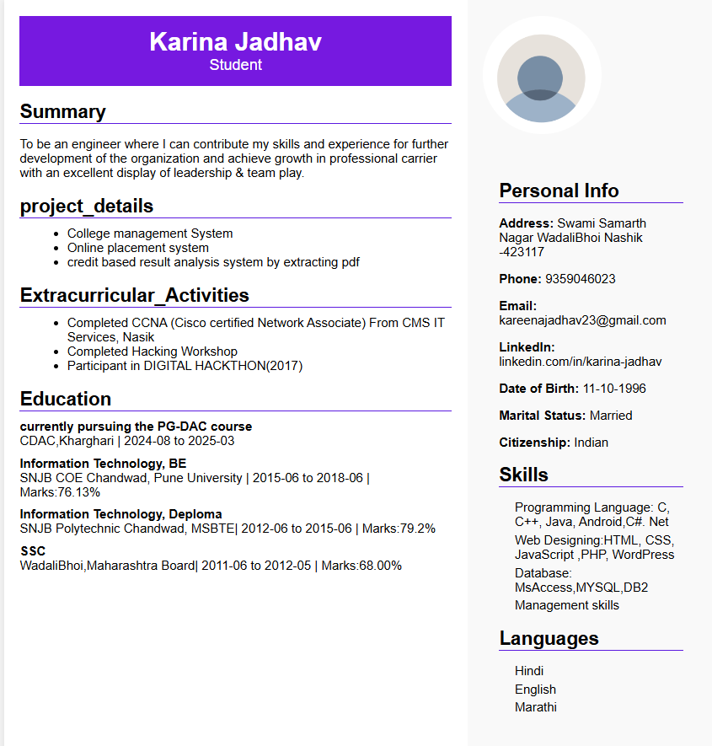

**2.Create Registration Form**

<html>

<head>

<title>Student Registration</title>

<style>

h2{

 font-family: Sans-serif;

 font-size: 24px;

 font-style: normal;

 font-weight: bold;

 color: rgb(234, 230, 243);

 text-align: center;

 text-decoration: underline

}

table{

 font-family: verdana;

 color:rgb(238, 233, 233);

 font-size: 16px;

 font-style: normal;

 font-weight: bold;

 background: linear-gradient(to bottom, #060606 0%, #0a0a0a 100%);

 border-collapse: collapse;

 border: 4px solid #000000;

 border-style: dashed;

}

table.inner{

 border: 10px

}

input[type=text], input[type=email], input[type=number]{

 width: 50%;

 padding: 6px 12px;

 margin: 5px 0;

 box-sizing: border-box;

}

input[type=submit], input[type=reset]{

 width: 15%;

 padding: 8px 12px;

 margin: 5px 0;

 box-sizing: border-box;

}

</style>

</head>

<body background="C:\Users\rushi\OneDrive\Desktop\IcGVtlX.webp">

<h2>Student Registration Form</h3>

<table align="center" cellpadding = "10">

<!--------------------- First Name ------------------------------------------>

<tr>

<td>First Name</td>

<td><input type="text" name="FirstName" maxlength="50" placeholder="karina" />

(Max 50 Characters Allowed)

</td>

</tr>

<!------------------------ Last Name --------------------------------------->

<tr>

<td>Last Name</td>

<td><input type="text" name="LastName" maxlength="50" placeholder="jadhav"/>

(Max 50 Characters Allowed)

</td>

</tr>

<!-------------------------- Email ID ------------------------------------->

<tr>

<td>Email ID</td>

<td><input type="email" name="EmailID" maxlength="100" placeholder="kareenajadhav23@gmail.com"/></td>

</tr>

<!-------------------------- Mobile Number ------------------------------------->

<tr>

<td>Mobile Number</td>

<td>

<input type="text" name="MobileNumber" maxlength="10" placeholder="7842xxxxxx"/>

(10 Digits Allowed)

</td>

</tr>

<!---------------------- Gender ------------------------------------->

<tr>

<td>Gender</td>

<td>

<input type="radio" name="Gender" value="Male" />

Male

<input type="radio" name="Gender" value="Female" />

Female

</td>

</tr>

<!--------------------------Date Of Birth----------------------------------->

<tr>

<td>Date of Birth(DOB)</td>

<td>

<select name="BirthDay" id="Birthday_Day">

<option value="-1">Day:</option>

<option value="1">1</option>

<option value="2">2</option>

<option value="3">3</option>

<option value="4">4</option>

<option value="5">5</option>

<option value="6">6</option>

<option value="7">7</option>

<option value="8">8</option>

<option value="9">9</option>

<option value="10">10</option>

<option value="11">11</option>

<option value="12">12</option>

<option value="13">13</option>

<option value="14">14</option>

<option value="15">15</option>

<option value="16">16</option>

<option value="17">17</option>

<option value="18">18</option>

<option value="19">19</option>

<option value="20">20</option>

<option value="21">21</option>

<option value="22">22</option>

<option value="23">23</option>

<option value="24">24</option>

<option value="25">25</option>

<option value="26">26</option>

<option value="27">27</option>

<option value="28">28</option>

<option value="29">29</option>

<option value="30">30</option>

<option value="31">31</option>

</select>

<select name="BirthdayMonth" id="Birthday_Month">

<option value="-1">Month:</option>

<option value="January">Jan(1)</option>

<option value="February">Feb(2)</option>

<option value="March">Mar(3)</option>

<option value="April">Apr(4)</option>

<option value="May">May(5)</option>

<option value="June">Jun(6)</option>

<option value="July">Jul(7)</option>

<option value="August">Aug(8)</option>

<option value="September">Sep(9)</option>

<option value="October">Oct(10)</option>

<option value="November">Nov(11)</option>

<option value="December">Dec(12)</option>

</select>

<select name="BirthdayYear" id="Birthday_Year">

<option value="-1">Year:</option>

<option value="2019">2019</option>

<option value="2018">2018</option>

<option value="2017">2017</option>

<option value="2016">2016</option>

<option value="2015">2015</option>

<option value="2014">2014</option>

<option value="2013">2013</option>

<option value="2012">2012</option>

<option value="2011">2011</option>

<option value="2010">2010</option>

<option value="2009">2009</option>

<option value="2008">2008</option>

<option value="2007">2007</option>

<option value="2006">2006</option>

<option value="2005">2005</option>

<option value="2004">2004</option>

<option value="2003">2003</option>

<option value="2002">2002</option>

<option value="2001">2001</option>

<option value="2000">2000</option>

<option value="1999">1999</option>

<option value="1998">1998</option>

<option value="1997">1997</option>

<option value="1996">1996</option>

<option value="1995">1995</option>

<option value="1994">1994</option>

<option value="1993">1993</option>

<option value="1992">1992</option>

<option value="1991">1991</option>

<option value="1990">1990</option>

<option value="1989">1989</option>

<option value="1988">1988</option>

<option value="1987">1987</option>

<option value="1986">1986</option>

<option value="1985">1985</option>

<option value="1984">1984</option>

<option value="1983">1983</option>

<option value="1982">1982</option>

<option value="1981">1981</option>

<option value="1980">1980</option>

</select>

</td>

</tr>

<!------------------------- Address ---------------------------------->

<tr>

<td>Address<br /><br /><br /></td>

<td><textarea name="Address" rows="10" cols="50"></textarea></td>

</tr>

<!-------------------------- City ------------------------------------->

<tr>

<td>City</td>

<td><input type="text" name="City" maxlength="50" placeholder="Nashik"/>

(Max 50 Characters Allowed)

</td>

</tr>

<!----- -------------------- Pin Code-------------------------------------->

<tr>

<td>Pin Code</td>

<td><input type="Number" name="PinCode" maxlength="6" placeholder="423117"/>

(Max 6 Numbers Allowed)

</td>

</tr>

<!---------------------------- State ----------------------------------->

<tr>

<td>State</td>

<td><input type="text" name="State" maxlength="50" placeholder="Maharashtra"/>

(Max 50 Characters Allowed)

</td>

</tr>

<!------------------------------ Country --------------------------------->

<tr>

<td>Country</td>

<td><input type="text" name="Country" placeholder="India" /></td>

</tr>

<!------------------------- Hobbies -------------------------------------->

<tr>

<td>Hobbies <br /><br /><br /></td>

<td>

<input type="checkbox" name="HobbyDrawing" value="Drawing" />

Drawing

<input type="checkbox" name="HobbySinging" value="Singing" />

Singing

<input type="checkbox" name="HobbyDancing" value="Dancing" />

Dancing

<input type="checkbox" name="HobbyCooking" value="Cooking" />

Sketching

<br />

<input type="checkbox" name="HobbyOther" value="Other">

Others

<input type="text" name="Other_Hobby" maxlength="50" placeholder="Ex- Teaching" />

(Max 50 Characters Allowed)

</td>

</tr>

<!-----------------------Qualification---------------------------------------->

<tr>

<td>Qualification <br /><br /><br /></td>

<tr>

    <th></th>

    <th>Board / University</th>

    <th>Percentage</th>

    <th>Year of Passing</th>

  </tr>

  <tr>

    <td>10th</td>

    <td><input type="text" name="10-board" required></td>

    <td><input type="text" name="10-percentage" required></td>

    <td><input type="text" name="10-year-of-passing" required></td>

  </tr>

  <tr>

    <td>12th</td>

    <td><input type="text" name="12-board" required></td>

    <td><input type="text" name="12-percentage" required></td>

    <td><input type="text" name="12-year-of-passing" required></td>

  </tr>

  <tr>

    <td>Graduation</td>

    <td><input type="text" name="grd-board" required></td>

    <td><input type="text" name="grd-percentage" required></td>

    <td><input type="text" name="grd-year-of-passing" required></td>

  </tr>

<!---------------------------- Courses ----------------------------------->

<tr>

<td>Courses<br />Applied For</td>

<td>

<input type="radio" name="CourseBCA" value="BCA">

BCA(Bachelor of Computer Applications)<br>

<input type="radio" name="CourseBE" value="B.E">

B.E(Bachelor of Engineering)<br>

<input type="radio" name="CourseBCom" value="B.Com">

B.Com(Bachelor of Commerce)<br>

<input type="radio" name="CourseBSc" value="B.Sc">

B.Sc(Bachelor of Science)<br>

<input type="radio" name="CourseBE" value="B.A">

BA(Bachelor of Arts)<br>

<input type="radio" name="CourseMCA" value="BCA">

MCA(Master of Computer Applications)<br>

<input type="radio" name="CourseMCom" value="B.Com">

M.Com(Master of Commerce)<br>

<input type="radio" name="CourseMSc" value="B.Sc">

M.Sc(Master of Science)<br>

<input type="radio" name="CourseMA" value="M.A">

MA(Master of Arts)<br>

</td>

</tr>

<!----------------------- Submit and Reset ------------------------------->

<tr>

<td colspan="2" align="center">

<input type="submit" value="Submit">

<input type="reset" value="Reset">

</td>

</tr>

</table>

</form>

</body>

</html>

Output:

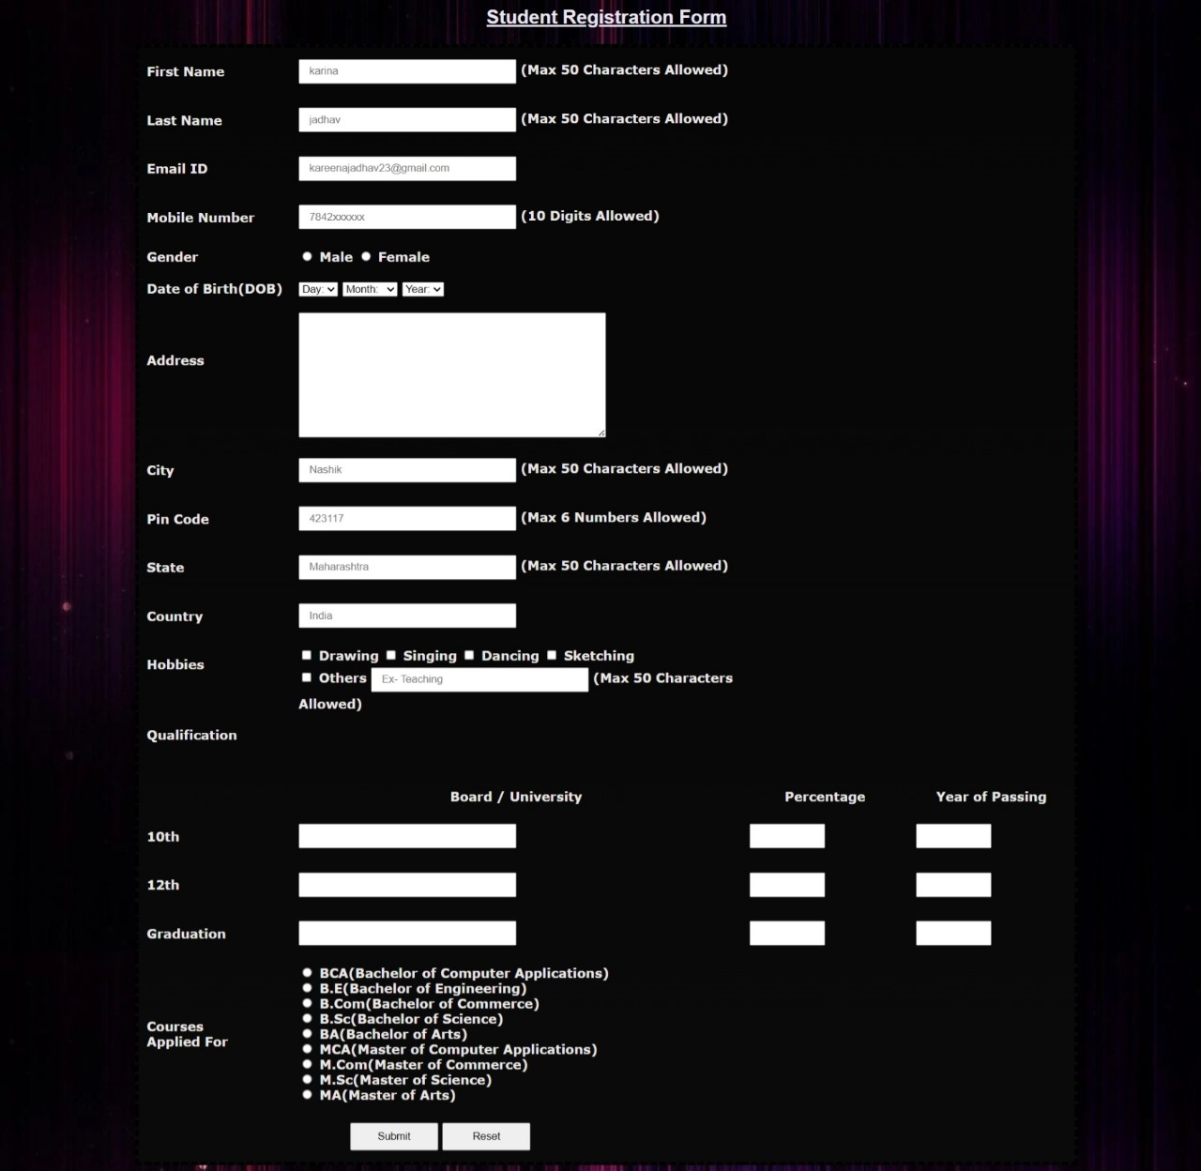

**3.Create a Signup page :**

HTML CODE:

<!DOCTYPE html>

<!-- Created By CodingNepal -->

<html lang="en" dir="ltr">

   <head>

      <meta charset="utf-8">

      <title>Login Form Design | CodeLab</title>

      <link rel="stylesheet" href="login.css">

   </head>

   <body>

      <div class="wrapper">

         <div class="title">

            Login Form

         </div>

         <form action="#">

            <div class="field">

               <input type="text" required>

               <label>Email Address</label>

            </div>

            <div class="field">

               <input type="password" required>

               <label>Password</label>

            </div>

            <div class="content">

               <div class="checkbox">

                  <input type="checkbox" id="remember-me">

                  <label for="remember-me">Remember me</label>

               </div>

               <div class="pass-link">

                  <a href="#">Forgot password?</a>

               </div>

            </div>

            <div class="field">

               <input type="submit" value="Login">

            </div>

            <div class="signup-link">

               Not a member? <a href="#">Signup now</a>

            </div>

         </form>

      </div>

   </body>

</html>

CSS CODE:

@import url('https://fonts.googleapis.com/css?family=Poppins:400,500,600,700&display=swap');

*{

  margin: 0;

  padding: 0;

  box-sizing: border-box;

  font-family: 'Poppins', sans-serif;

}

html,body{

  display: grid;

  height: 100%;

  width: 100%;

  place-items: center;

  background: #f2f2f2;

  /* background: linear-gradient(-135deg, #c850c0, #4158d0); */

}

::selection{

  background: #4158d0;

  color: #fff;

}

.wrapper{

  width: 380px;

  background: #fff;

  border-radius: 15px;

  box-shadow: 0px 15px 20px rgba(0,0,0,0.1);

}

.wrapper .title{

  font-size: 35px;

  font-weight: 600;

  text-align: center;

  line-height: 100px;

  color: #fff;

  user-select: none;

  border-radius: 15px 15px 0 0;

  background: linear-gradient(-135deg, #c850c0, #4158d0);

}

.wrapper form{

  padding: 10px 30px 50px 30px;

}

.wrapper form .field{

  height: 50px;

  width: 100%;

  margin-top: 20px;

  position: relative;

}

.wrapper form .field input{

  height: 100%;

  width: 100%;

  outline: none;

  font-size: 17px;

  padding-left: 20px;

  border: 1px solid lightgrey;

  border-radius: 25px;

  transition: all 0.3s ease;

}

.wrapper form .field input:focus,

form .field input:valid{

  border-color: #4158d0;

}

.wrapper form .field label{

  position: absolute;

  top: 50%;

  left: 20px;

  color: #999999;

  font-weight: 400;

  font-size: 17px;

  pointer-events: none;

  transform: translateY(-50%);

  transition: all 0.3s ease;

}

form .field input:focus ~ label,

form .field input:valid ~ label{

  top: 0%;

  font-size: 16px;

  color: #4158d0;

  background: #fff;

  transform: translateY(-50%);

}

form .content{

  display: flex;

  width: 100%;

  height: 50px;

  font-size: 16px;

  align-items: center;

  justify-content: space-around;

}

form .content .checkbox{

  display: flex;

  align-items: center;

  justify-content: center;

}

form .content input{

  width: 15px;

  height: 15px;

  background: red;

}

form .content label{

  color: #262626;

  user-select: none;

  padding-left: 5px;

}

form .content .pass-link{

  color: "";

}

form .field input[type="submit"]{

  color: #fff;

  border: none;

  padding-left: 0;

  margin-top: -10px;

  font-size: 20px;

  font-weight: 500;

  cursor: pointer;

  background: linear-gradient(-135deg, #c850c0, #4158d0);

  transition: all 0.3s ease;

}

form .field input[type="submit"]:active{

  transform: scale(0.95);

}

form .signup-link{

  color: #262626;

  margin-top: 20px;

  text-align: center;

}

form .pass-link a,

form .signup-link a{

  color: #4158d0;

  text-decoration: none;

}

form .pass-link a:hover,

form .signup-link a:hover{

  text-decoration: underline;

}

Output:

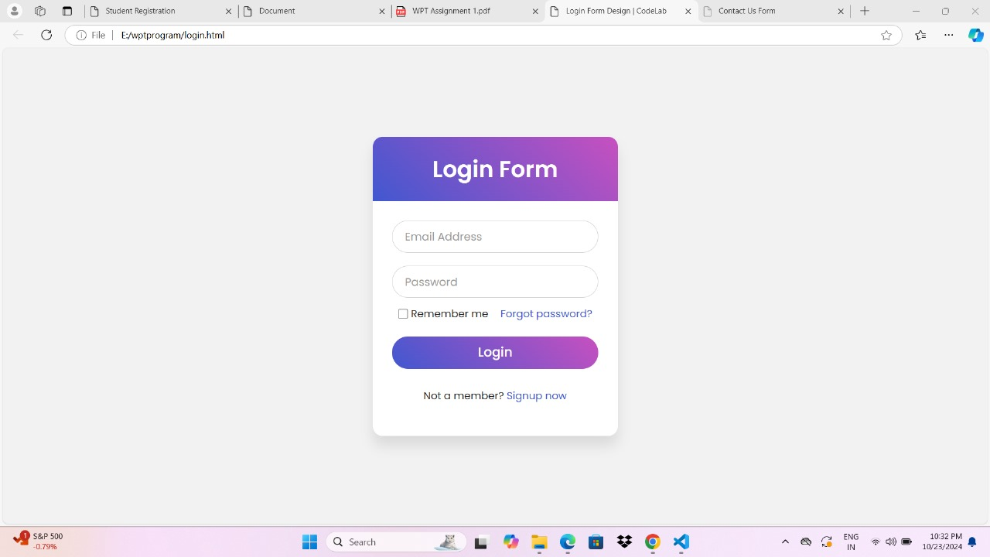

**4.Create a Contact Us page:**

HTML CODE:

<!DOCTYPE html>

<html lang="en">

<head>

    <meta charset="UTF-8">

    <meta name="viewport" content="width=device-width, initial-scale=1.0">

    <title>Contact Us Form</title>

    <link rel="stylesheet" href="concat.css">

</head>

<body>

    <div class="contact-form">

        <h2>Contact Us</h2>

        <form action="#" method="post">

            <div class="input-box">

                <label for="name">Name</label>

                <input type="text" id="name" name="name" placeholder="Enter your name" required>

            </div>

            <div class="input-box">

                <label for="email">Email</label>

                <input type="email" id="email" name="email" placeholder="Enter your email" required>

            </div>

            <div class="input-box">

                <label for="subject">Subject</label>

                <input type="text" id="subject" name="subject" placeholder="Subject" required>

            </div>

            <div class="input-box">

                <label for="message">Message</label>

                <textarea id="message" name="message" rows="4" placeholder="Your message" required></textarea>

            </div>

            <div class="input-box">

                <input type="submit" value="Send Message">

            </div>

        </form>

    </div>

</body>

</html>

CSS CODE:

* {

    margin: 0;

    padding: 0;

    box-sizing: border-box;

    font-family: Arial, sans-serif;

}

body {

    background-color: #f3f4f6;

    display: flex;

    justify-content: center;

    align-items: center;

    height: 100vh;

}

.contact-form {

    background-color: white;

    padding: 30px;

    border-radius: 10px;

    box-shadow: 0 4px 8px rgba(0, 0, 0, 0.1);

    width: 400px;

}

.contact-form h2 {

    text-align: center;

    margin-bottom: 20px;

    font-size: 24px;

    color: #333;

}

.input-box {

    margin-bottom: 15px;

}

.input-box label {

    display: block;

    margin-bottom: 5px;

    color: #333;

}

.input-box input, .input-box textarea {

    width: 100%;

    padding: 10px;

    border: 1px solid #ddd;

    border-radius: 5px;

    font-size: 16px;

    color: #555;

}

.input-box input[type="submit"] {

    background-color: #28a745;

    color: white;

    cursor: pointer;

    font-weight: bold;

    border: none;

}

.input-box input[type="submit"]:hover {

    background-color: #218838;

}

Output:

